English Comprehension (Eng101)

Fall 2019
Assignment No. 1
Total Marks: 20
Lectures: 1-10

Instructions:

- Upload your assignments in a proper format, i.e. MS word file. Corrupt files will be awarded zero marks.
- The assignments should be zoomed in at 100%.
- Please avoid plagiarism; plagiarized work will be marked zero.
- After the due date, the assignments submitted via email would not be entertained.
- Please avoid submitting copied assignments; otherwise, such a case would be referred to the discipline committee.
- The font color should be preferably black and font size 12 Times New Roman.

Q1. Creative writing is a subjective creation of a picture of the world. It is an expression of the realization of the joys and sorrows, as well as a way to let one's imagination run wild. The picture has a context and contains a story. Look at the following picture and write a short imaginary story of 100-150 words.
10 Marks
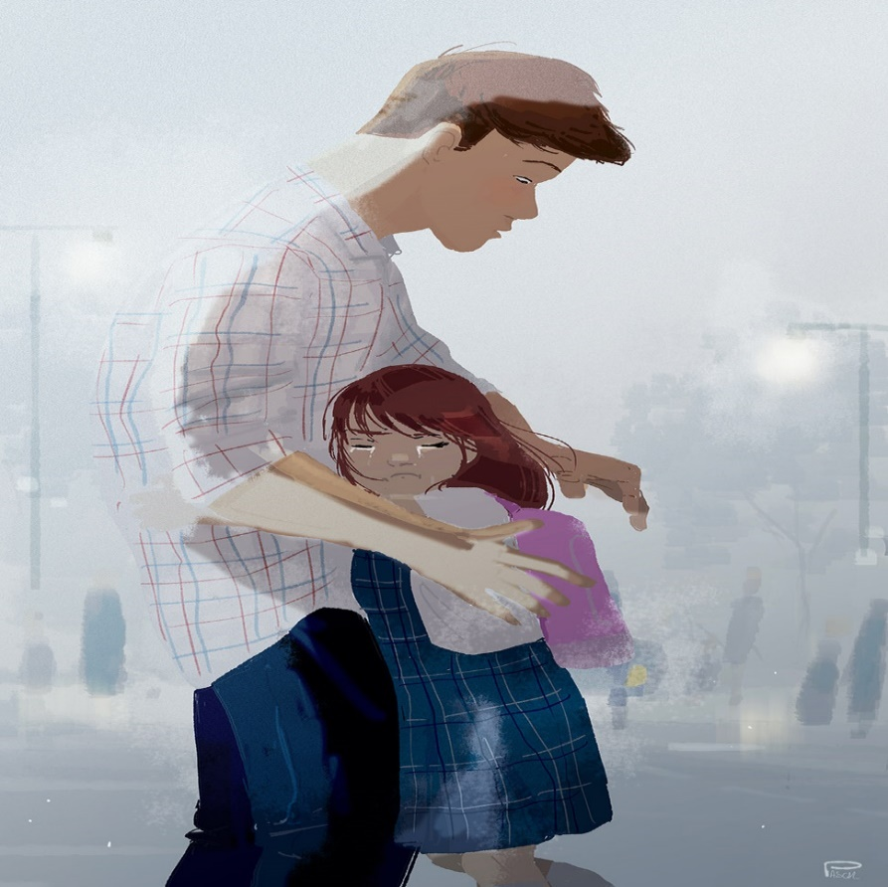

Q2. Recall your knowledge of writing paragraphs and inferring a text. Read the given passages and poetic stanzas carefully and answer the questions that follow them.

Note: Write only answers of the questions. Please don’t paste all of the text.

1. The Road is one of the great fundamental institutions of mankind. Not only is the Road one of the great human institutions because it is fundamental to social existence, but also because it’s varied effects appear in every department of the State. It is the Road which determines the sites of many cities and the growth and nourishment of all. It is the Road which controls the development of strategies and fixes the sites of battles. It is the Road that gives its framework to all economic development. It is the Road which is the channel of all trade, and, what is more important, of all ideas. In its most humble function it is a necessary guide without which progress from place to place would be a ceaseless experiment; it is a sustenance without which organized society would be impossible, thus the Road moves and controls all history.

Which one of the following statements is the topic sentence of the above paragraph?
- It is the Road which determines the sites of many cities and the growth and nourishment of all.
- It is the Road which is the channel of all trade.
- The Road is one of the great fundamental institutions of mankind.
- It is the Road that gives its framework to all economic development.

2. Black-marketing is another curse. Well, I know that black-marketers are frequently caught and punished. According to our judicial notions sentences are passed, and sometimes fines only are imposed. Now you have to tackle this monster which today is a colossal crime against society, in our distressed conditions, when we constantly face shortage of food and or the essential commodities of life. A citizen who does black-marketing commits, I think, a greater crime than the biggest and most grievous of crimes. These black-marketers are really knowing, intelligent and ordinarily responsible people, and when they indulge in black-marketing, I think they ought to be very severely punished, because they undermine the entire system of control and regulation of food-stuffs and essential commodities, and cause wholesale starvation and want and even death.
Which of the following statements suggest the best way to control black marketing?
- Transparency should be introduced in financial transactions.
- Small fines should be imposed on black-marketers.
- Black-marketers ought to be severely punished.
- None of these

3. When I have fears that I may cease to be
Before my pen has gleaned my teeming brain,
Before high-pilèd books, in charactery,
Hold like rich garners the full ripened grain;
When I behold, upon the night’s starred face,

What does the poet fear in the first stanza of the poem?
- Fear of becoming famous
- Fear of death
- Fear of writing poetry
- None of these

4. Without education it is complete darkness and with education it is light. Education is a matter of life and death to our nation. The world is moving so fast that if you do not educate yourselves you will be not only completely left behind, but will be finished up. The Holy Prophet (PBUH) had enjoined his followers to go even to China in the pursuit of knowledge. If that was the commandment in those days when communications were difficult, then, truly, Muslims as the true followers of the glorious heritage of Islam, should surely utilize all available opportunities. No sacrifice of time or personal comfort should be regarded too great for the advancement of the cause of education.

Which one of the following statements highlights the main idea of the above mentioned paragraph?
- Education is a matter of life and death to our nation.
- Without education it is complete darkness and with education it is light.
- The world is moving so fast that if you do not educate yourselves you will be not only completely left behind.
- The Holy Prophet (PBUH) had enjoined his followers to go even to China in the pursuit of knowledge.

5. I was angry with my friend;
I told my wrath, my wrath did end.
I was angry with my foe:
I told it not, my wrath did grow.
And I watered it in fears,
Night & morning with my tears:
And I sunned it with smiles,
And with soft deceitful wiles.

In the above lines, the speaker watered:
- Fear
- Love
- Anger
- Wrath

